Members of the Czech Nonet

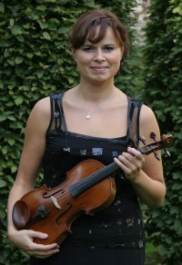
Romana Zieglerová – violin (1977) She studied at the Conservatoire in Brno, Czech Republic (Prof. Bohumil Kotmel) and at the Academy of Performing Arts in Prague, Czech Republic (Prof. Vaclav Snitil). She was given a scholarship to study violin in Tasmania, Australia in 2001-2002 (Prof. Jan Sedivka). Romana finished these studies achieving title The Master of Music. She played many solo recitals for Australian audience and even organised "Concert of the Czech Music" in Hobart to collect funds to help people in the Czech Republic to renovate country after devastating floods in summer 2002. She has been member of the Prague Philharmonia since 1998 and its Concert Master since 2004. In 2005, Romana Zieglerova went back to Australia, where she not only gave solo recitals but also as worked as a teacher in residence at the Hobbart Conservatory. Due to her success, she has been reinvited to come back again in 2007. Later that year, Romana performed Beethoven's triple concerto together with the Algerian Symphonic Orchestra at the 6th European Culture Festival. She also participated at the final concert of the Prague Music Festival together with the Janacek's Philharmonic Orchestra and its chief conductor Maestro Theodor Kuchar. In 2006, she gave many concerts as the Concert Master of the Prague Philharmonia, but also as a soloist, for example with the Prague Symphony Orchestr under conductor Maxim Shostakovich. She joined the Czech Nonet in 2006.

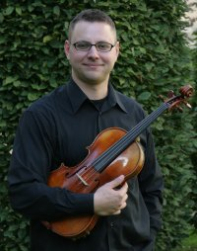
Vladimír Kroupa – viola (1973) finished The Prague Conservatory with J Ruis (Dvořák Quartet), then read viola with L Malý at The Academy of Performing Arts in Prague. He was a member of the Talich Chamber Orchestra and of the Czech Philharmonic Orchestra (for two years). From 1991, he played in the Apollon String Quartet, who won the first prize at the L van Beethoven international competition. In 1996, he participated in master classes with the Alban Berg Quartet, and in 2000 with H.W.Meyer (LaSalle Quartet).In 1999 he was one of the founding members of the Epoque String Quartet which performed in Germany, Austria, Switzerland, France, Italy, Britain, Israel, Japan, Greece, the Netherlands etc, and which was successful at many competitions (e.g. the Paolo Borciani Competition) and festivals (e.g. Schleswig-Holstein Festival (Germany), Stuttgarter Philharmoniker Zyklus, Metamorphosen (Switzerland), České sny (the Czech Republic)). In 2000 he led master classes at The Jerusalem Academy of Music and Dance. Since 2003, he has been a member of The Prague Radio Symphony Orchestra (SOČR) where he is leading viola player at present. He has been a member of the Czech Nonet since 2007.
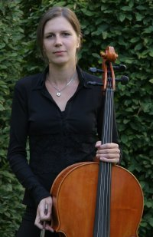

Simona Hečova - Violoncello (1976) studied at the Prague Conservatory and the Academy of Music, with M. Mlejnik in Klagenfurt and B. Pergamenschikow and F. Helmerson in Lubeck. Prizes included Boris Heran (1986) and Liezen, Austria (1992 and 1994). She records for the Czech Radio.

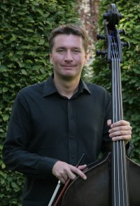
Radovan Heč – double-bass (1974) studied at the Prague Conservatory and the Academy of Music as well as in master classes with Maurice Bourge, Boris Pergamenschikow and Sandor Vegh. He won prizes at the international double bass competitions in Brno, Czech Republic in 1998 and Markneukirchen, Germany in 1999. In 2000 his solo performances with the Brno Philharmonia and Czechoslovakian Chamber Orchestra were broadcast by Czech Radio. He was a member of the Czech Radio Symphony Orchestra in 2003-2004 and has been a member of the Prague Chamber Orchestra since 2003. He has been a member of the Czech Nonet since 1996 and regularly performs as a chamber duo with his sister, Simona Hecova.

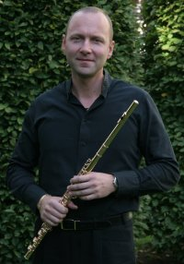

Jiri Skuhra - flute (1970) studied at the Prague Conservatory and the Academy of Music. He is prize winner of Concertino Praga, solo flute of State Opera Prague, member of Prague Wind Harmony, and since 1993 the Czech Nonet.

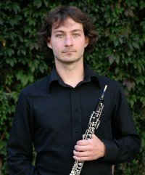
Vladislav Borovka – oboe (1976) studied at the Pague Conservatory in 1990-1996 with professor Bedrich Voboril. He received prizes in the National Conservatory Contest in Kromeriz (1994) and in the Concertino Praga competition. Since 1994, he has been a member of the Prague Philharmonia. He also gained performing experiences with M. Bourgue, T. Cammaert, G. Passin; in 2000 he received a scholarship of the Yamaha company. In 2001, he graduated from the Academy of Music in Prague (professor Jiri Mihule) and became the Laureate of the Prague Spring Competition. In 2001-2002, he studied with J. L. Capezzali at the Conservatoire Paul Dukas. Since 2004, he teaches at the Prague Conservatory. Since 2005, he has been a member of the Czech Nonet.

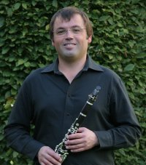
Ales Hustoles – klarinet (1970) studied at the Prague Conservatory and the Academy of Music and won several prizes. He is a member of the Opera Mozart, Prague Wind Harmony and since 1994 the Czech Nonet.

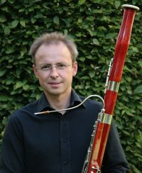
Pavel Langpaul – bassoon (1970) studied at the Prague Conservatory and the Academy of Music and won several prizes including Prague Spring. He is solo basson with the National Theater, Opera Mozart, Prague Wind Harmony and since 1994 the Czech Nonet.

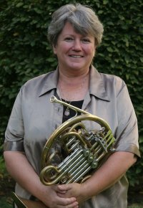
Vladimíra Klánská - French horn (1947) studied at the Prague Conservatory and later at the Academy of Music with Vladimir Kubat. She is a winner of the Munich ARD competition and has been solo horn with the Prague Symphony Orchestra. Member of the Prague Wind Quintet 1980 - 2002 (artistic leader since 1992). Guest artist of the IHS Annual workshop in Munich and Cansas City. President of the Stich-Punto Horn Society 1989-1993. Masterclasses in the Czech Republic, France, USA, Brazil and Japan. Professor of the Horn Class at the Jan Neruda Gymnasium in Prague since 1996. She is very active in chamber music, and as a soloist and recording artists. Therapeut in the "One Brain" system. Member of the Czech Nonet since 1982, artistic leader 1991-2003. Dramaturgist of the chamber music series of the Czech Nonet "Music and Paintings" since 1994. Juror of international music competitions

