Tomas Brauner | Conductor

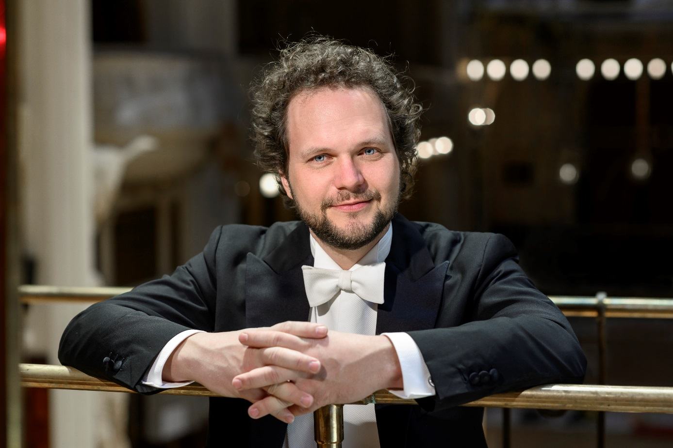
Chief Conductor and Music Director of the PRAGUE SYMPHONY ORCHESTRA

Czech conductor Tomas Brauner (a laureate of the Dimitris Mitropoulos International Conducting Competition in Athens) was appointed the new chief conductor and artistic director of the Prague Symphony Orchestra, the Czech Republic finest orchestras with an almost 100 year of musical tradition.

Brauner will continue serving for the next two seasons as the chief conductor of the Bohuslav Martinů Philharmonic Orchestra (Zlin, Czech Republic). From 2013-2018 Tomas Brauner held the position Chief conductor of Pilsen Philharmonic Orchestra.

Tomas Brauner regularly cooperates with leading European symphonic orchestra. His guest appearances have seen him conducting the Czech Philharmonic Orchestra, Deutsche Radio Philharmonie Saarbrücken, Munich Symphony Orchestra, Nürnberger Symphoniker, Moscow Radio State Orchestra, The Cracow Philharmonic, National Radio Orchestra Romania, Prague Philharmonia, Slovak State Philharmonic, Prague Radio Symphony Orchestra, Czech National Symphony Orchestra, Orchestra of Colours Athens, Janáček Philharmonic Ostrava, Prague Chamber Orchestra, Kosice State Philharmonic, Moravian Philharmonic Olomouc, and others.
Active as both an orchestra and opera conductor, Brauner’s performance of Janáček's opera Jenůfa at the Palacio de Bellas Artes in Mexico City received much acclaim. At the Palacio de Bellas Artes in Mexico City, Tomas Brauner has also conducted ballet performances of Swan Lake and Sleeping Beauty by Tchaikovsky.

At the Prague State Opera, he debuted conducting Verdi’s Othello. He has since conducted numerous operas at the Prague State Opera, including Don Quijote by Massenet, The Barber of Seville by Rossini, La Bohéme and Tosca by Puccini, Nabucco by Verdi, Carmen by Bizet, The Magic Flute by Mozart, along with a concert performance of Mignon by Ambrois Thomas, and Giselle by Adam.
Tomas Brauner has conducted the Pilsen Opera Theatre (Czech Republic) production premieres of La Gioconda by Ponchielli, Don Giovanni by Mozart, Maid of Orleans by Tchaikovsky, Il Turco di Italia by Rossini, Jacobin by Dvořák, Turandot by Puccini, Faust by Gounod, Adriana Lecouvreur by Francesco Cilea and many others. He has also conducted a new production of Hunchback of Notre Dame by Maurice Jarre (Opera Pilsen),

Tomáš Brauner conducted a new production Les Comptes de Hoffman at the Slovak National Theatre in 2019.
At the National Moravian-Silesian Theatre in Ostrava (Czech Republic), Brauner has conducted Nabucco and Ernani by Verdi, Maria Stuarda by Donizetti, Romeo and Juliet by Gounod, Hamlet by Thomas or Kátá Kabanova by Janáček.
Tomas Brauner has appeared as a guest conductor at significant international festivals such as the Richard Strauss Festival in Garmisch Parten-Kirchen where he has performed An Alpine Symphony with the Prague Radio Symphony Orchestra. He has also appeared at the Bad Kissingen International Music Festival, Prague Spring International Music Festival, Dvořák Prague International Festival Smetana´s Litomyšl International Opera Festival (Czech Republic), and at the International Music Festival Český Krumlov (Czech Republic).
Tomáš Brauner´s discography including recordings for Dabringhaus und Grimm such as Bohuslav Martinů: Complete works for Violoncello and Orchestra which won Classic Prague Music Awards the best recording 2017. Dvorak´s Slavonic Rhapsodies (Arco Diva) and for label of Czech Radio Radioservis Complete piano Concertos by Bohuslav Martinů and Thaikovsky´s Manfred and Fatum.

Tomáš Brauner studied the oboe and conducting at the Prague State Conservatory. He graduated from the Conducting the Academy of Performing Arts in Prague. He continued his conducting studies at the Universität für Musik und darstellende Kunst in Vienna with Prof. Uroš Lajovič. In 2017 Tomáš Brauner received the Art Prize of the City of Pilsen for outstanding artistic contribution.

